LAB 10

<https://leetcode.com/problems/symmetric-tree/submissions/1464808282>

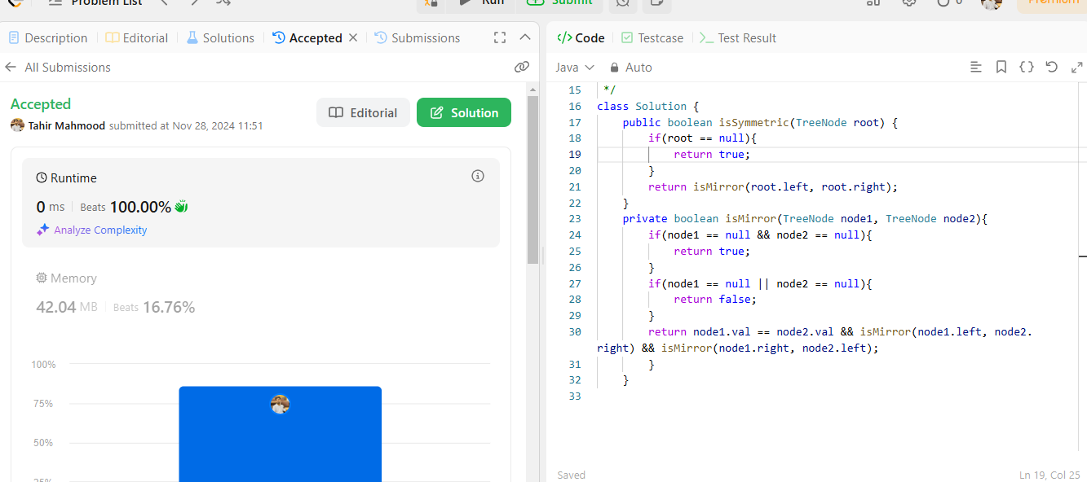

<https://leetcode.com/problems/invert-binary-tree/submissions/1464768911>

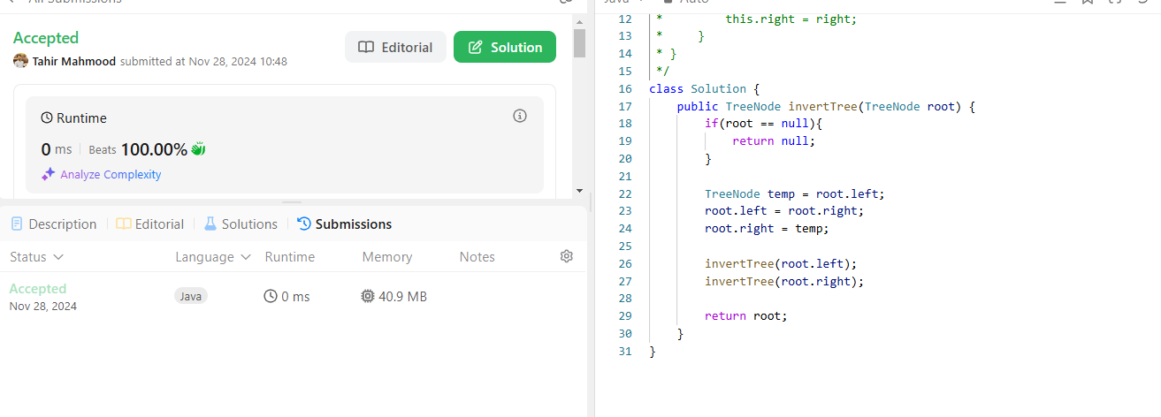

<https://leetcode.com/problems/path-sum/submissions/1464767092>

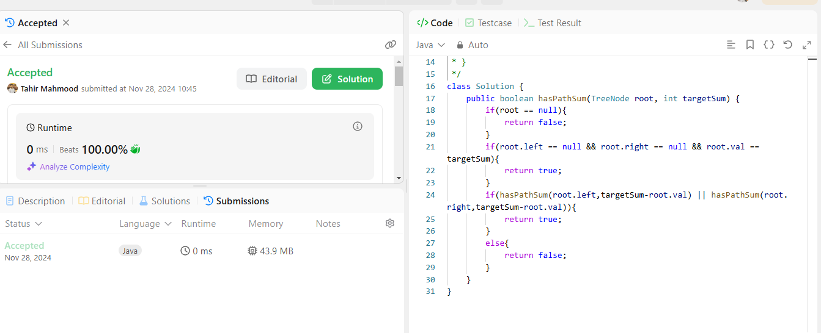

<https://leetcode.com/problems/maximum-depth-of-binary-tree/submissions/1464744476>

